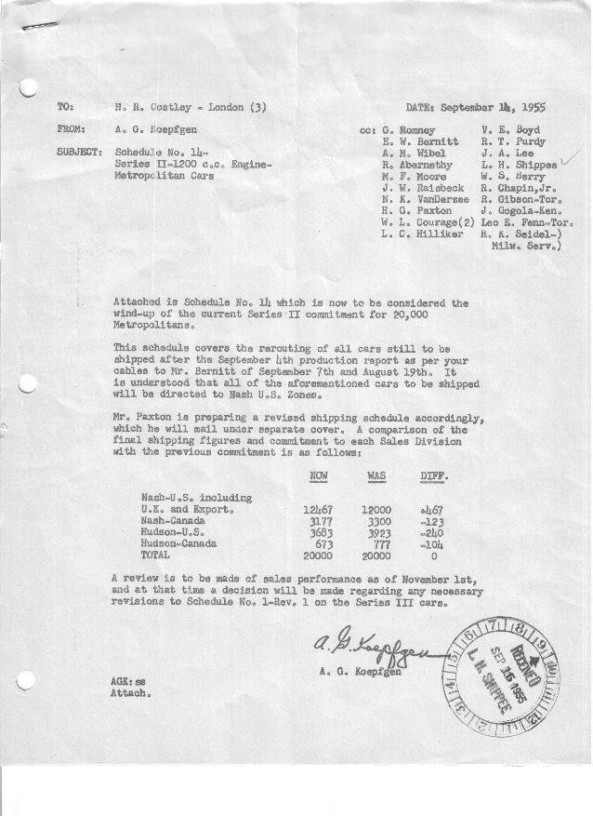

FORM PLAN 68 REV. 2-55-A.M.P APPROVED R. Abernethy & E.W. Bernitt (signed) DATE 9-12-55 & 9-13-55

SCHEDULE NO. ______14________ DATE 9-12 -55 MONTHLY BUILDING SCHEDULE APPROVED W. L Courage (signed)_ DATE_ 9-13-55 ____ REVISION NO. _______ _______ DATE __ PRODUCT APPROVED_R.T. Purdy (signed) ___________DATE_ 9-13-55 ____
-Final on Series II (1200 c.c. Engine)
Metropolitan Series Cars – Austin Motors Co., Ltd. England
DESCRIPTION | BUILT  ACT◻ EST  THRU  9/4/55 | FIRM BUILDING SCHEDULE  (FABRICATED MATERIAL RELEASE) |  |  |  |  |  |  |  |  |  |  |  |  |  |  | TENTATIVE SCHEDULE  (RAW MATERIAL RELEASED) |  |  | GRAND  TOTAL
DESCRIPTION | BUILT  ACT◻ EST  THRU  9/4/55 | MONTH September  DAYS 20 (Balance) |  |  | MONTH October  DAYS 21 |  |  | MONTH November  DAYS 22 |  |  | MONTH  DAYS |  |  | MONTH  DAYS |  |  |  |  |  | GRAND  TOTAL
DESCRIPTION | BUILT  ACT◻ EST  THRU  9/4/55 | DAILY | MONTH | CUM’L  TOTAL | DAILY | MONTH | CUM’L  TOTAL | DAILY | MONTH | CUM’L  TOTAL | DAILY | MONTH | CUM’L  TOTAL | DAILY | MONTH | CUM’L  TOTAL | DAILY | MONTH | TOTAL | GRAND  TOTAL
NASH
Hard-Top | 10359 |  | 258 | 10617 |  | 273 | 10890 |  | 286 | 11176
Soft-Top | 4468 |  | 0 | 4468 |  | 0 | 4468 |  | 0 | 4468
Sub-Total | 14827 |  | 258 | 15085 |  | 273 | 15358 |  | 286 | 15644
Over/(Under) Sched. #13 |  |  | - | 176 |  | 81 | 257 |  | 87 | 344
HUDSON
Hard-Top | 3820 |  | 0 | 3820 |  | 0 | 3820 |  | 0 | 3820
Soft-Top | 536 |  | 0 | 536 |  | 0 | 536 |  | 0 | 536
Sub-Total | 4356 |  | 0 | 4356 |  | 0 | 4356 |  | 0 | 4356
Over/(Under) Sched. #13 |  |  | - | (176) |  | (81) | (257) |  | (87) | (344)
GRAND TOTALS
Hard-Top | 14179 |  | 258 | 14437 |  | 273 | 14710 |  | 286 | 14996
Soft-Top | 5004 |  | 0 | 5004 |  | 0 | 5004 |  | 0 | 5004
Total | 19183 |  | 258 | 19441 |  | 273 | 19714 |  | 286 | 20000
Over/(Under) Sched. #13 |  |  | - | - |  | - | - |  | - | -

